**Project – 1**

**Brain-Tasks-App**

1. **GIT Clone:**

* Cloned the GitHub repo

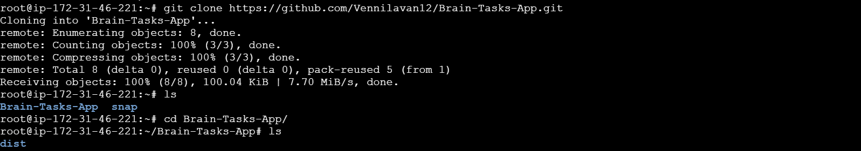

1. Dockerized the app

* Installed the Docker

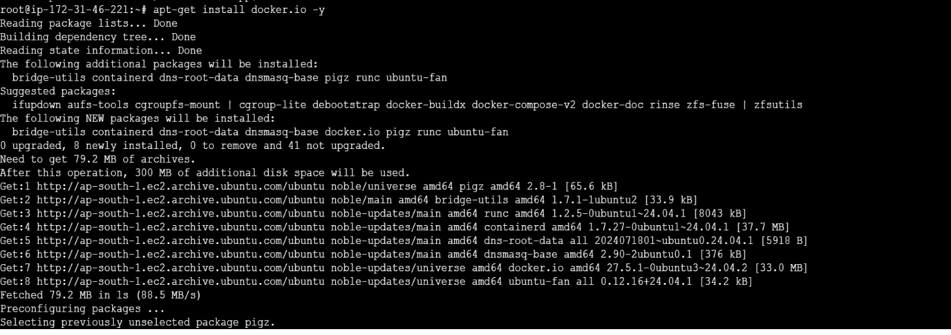

* **Docker Version**



* **Dockerfile:** stepwise instructions to build the image

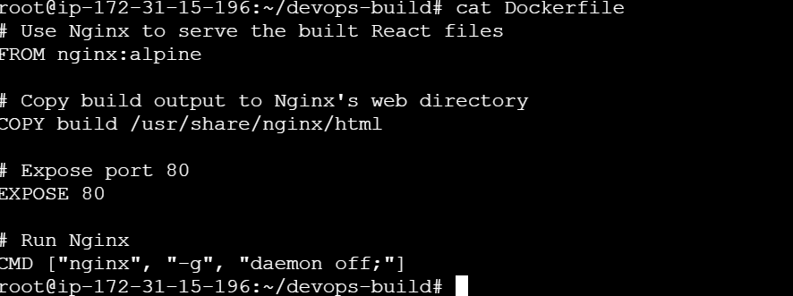

* **Multi-stage build**: build artifacts in one stage, copy only final assets into a small runtime image (keeps images small).

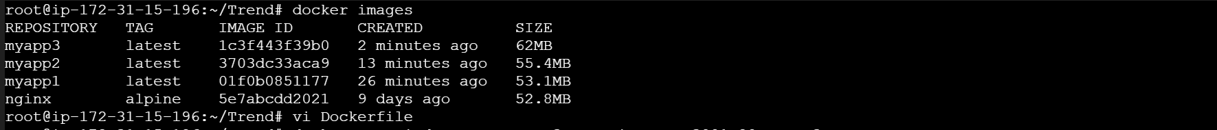

* **Containerization (Docker)**

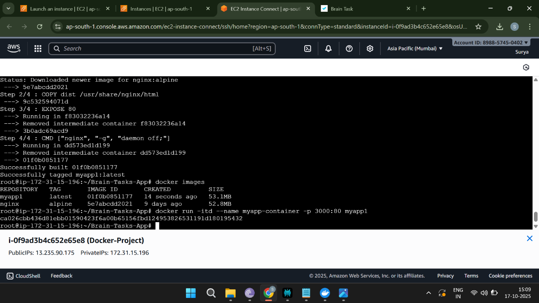

* **Output**

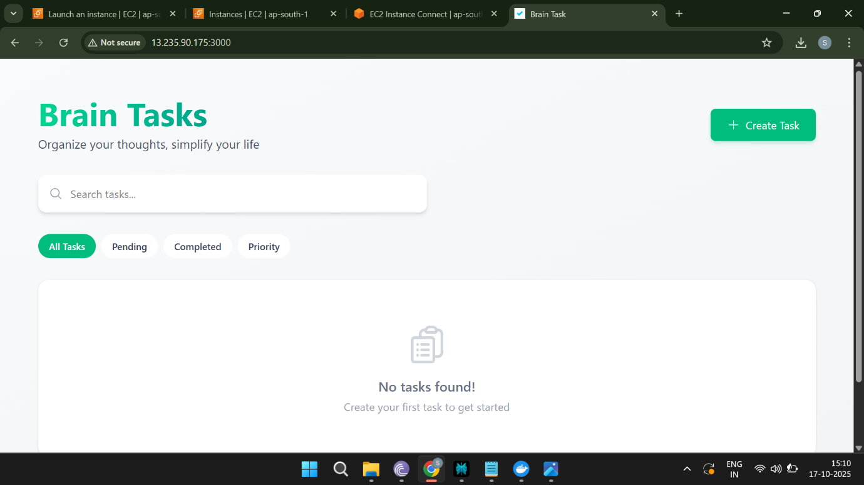

1. ECR:

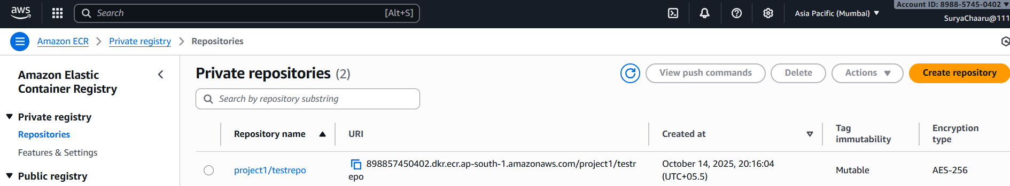

Created an AWS ECR repository

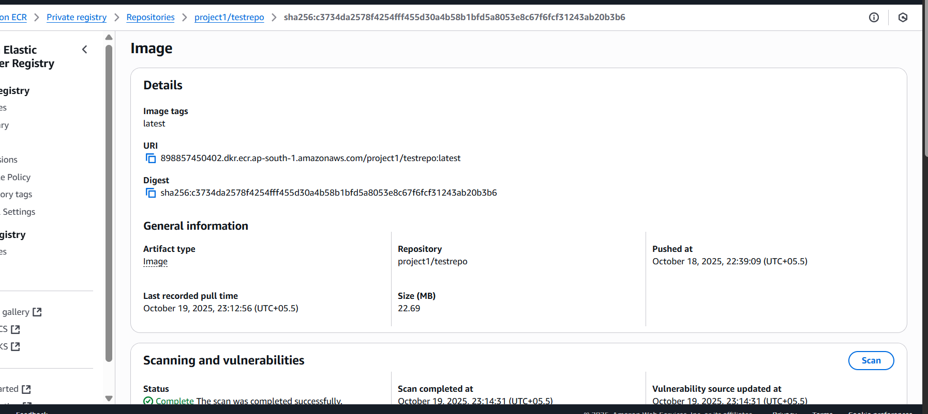

Pushed docker images.

1. Kubernetes:

* **Create EKS Management Host in AWS:**
* **installed kubectl using below commands,**

**curl -o kubectl** [**https://amazon-eks.s3.us-west-2.amazonaws.com/1.19.6/2021-01- 05/bin/linux/amd64/kubectl**](https://amazon-eks.s3.us-west-2.amazonaws.com/1.19.6/2021-01-%20%20%20%20%2005/bin/linux/amd64/kubectl)

**chmod +x ./kubectl**

**sudo mv ./kubectl /usr/local/bin**

**kubectl version --short –client**

* **Installed AWS CLI by using commands:**

**sudo apt install unzip**

**curl "https://awscli.amazonaws.com/awscli-exe-linux-x86_64.zip" -o "awscliv2.zip"**

**unzip awscliv2.zip**

**sudo ./aws/install**

**aws –version**

* **Installed eksctl :**

**curl --silent --location "https://github.com/weaveworks/eksctl/releases/latest/download/eksctl_$(uname -s)_amd64.tar.gz" | tar xz -C /tmp**

**sudo mv /tmp/eksctl /usr/local/bin**

**eksctl version**

* **Create IAM role & attach to EKS Management**

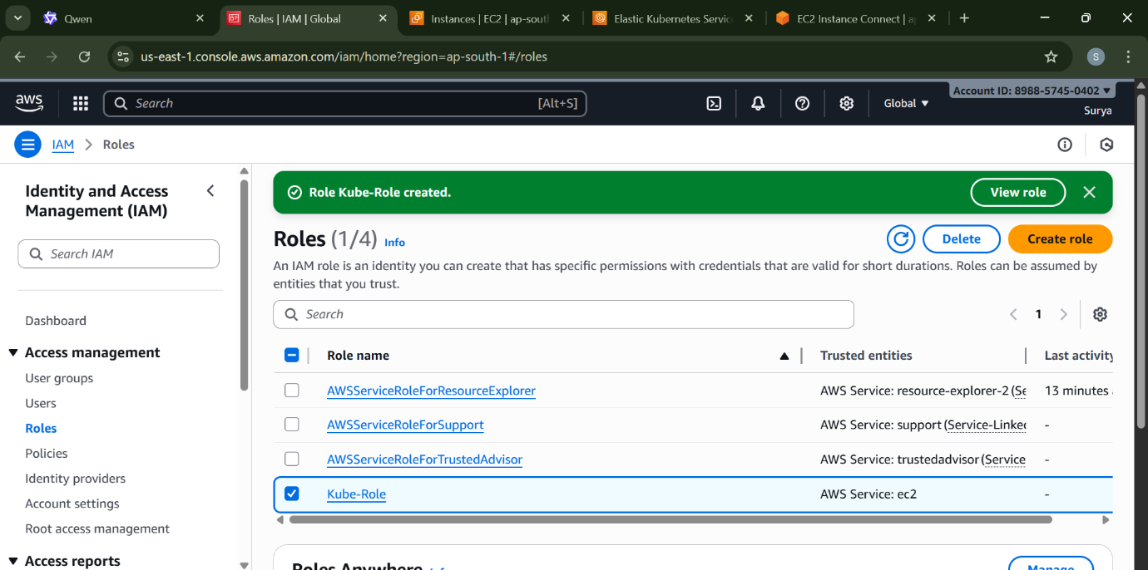

**Created a Cluster by using the command:**

* **eksctl create cluster --name mycluster1 --region us-east-2 --nodegroup-name project-node --node-type c7i-flex.large --nodes 2**

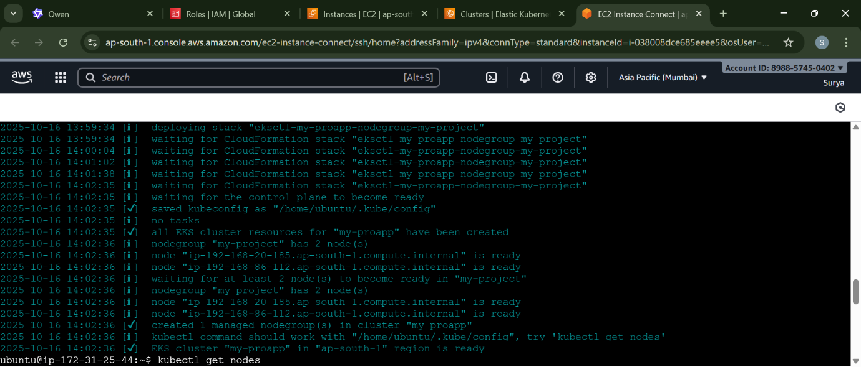

* **And pod.yaml file created:**

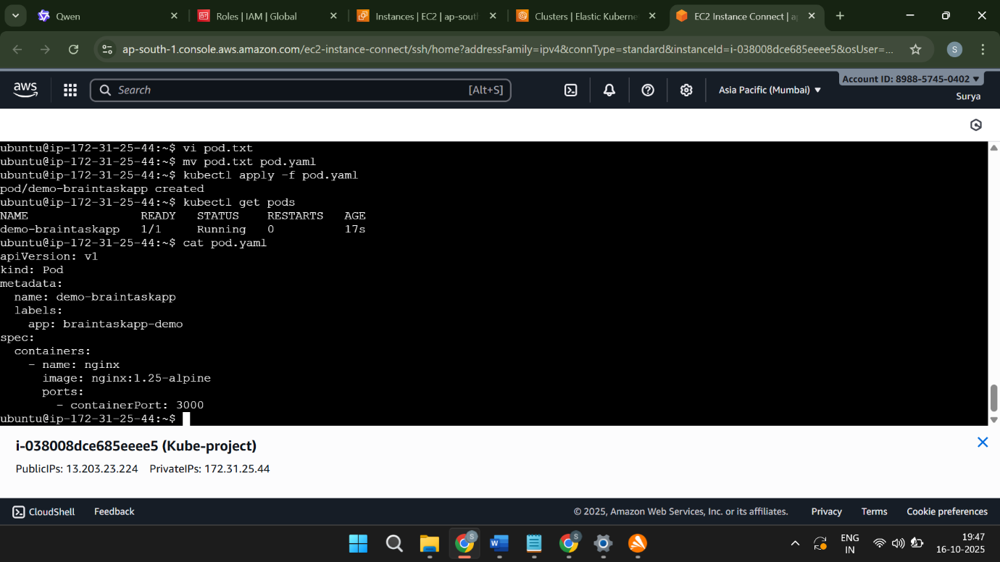

* Confirming that the EKS cluster is running.

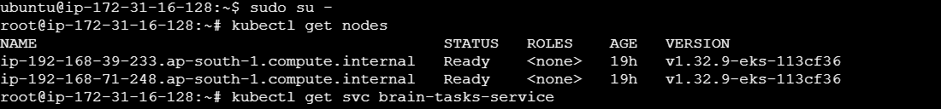

* Deployment and service YAML files.

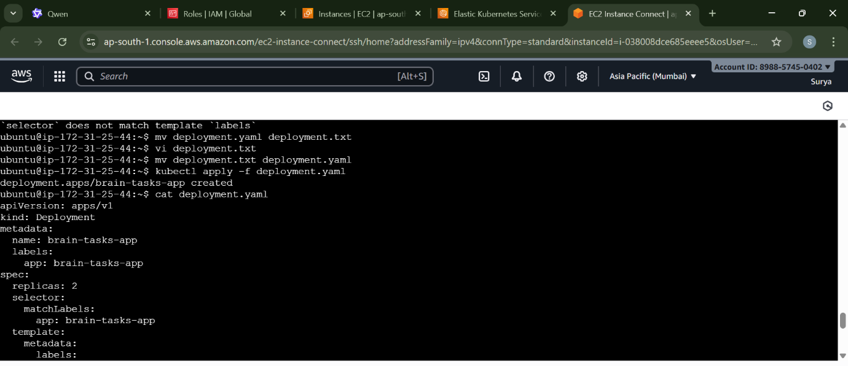

* Confirm pods are running and service gives you a LoadBalancer URL by using the following commands,

kubectl get svc brain-tasks-service

* Given a Load balancer URL:

<http://a5d53d9f91628496d9a7a926259cc170-1336712681.ap-south-1.elb.amazonaws.com:3000/>

* OutPut:

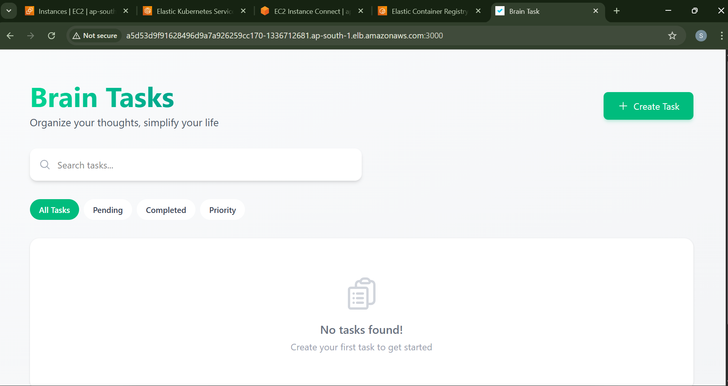

Deploy using kubectl via Codedeploy.

Created the cluster

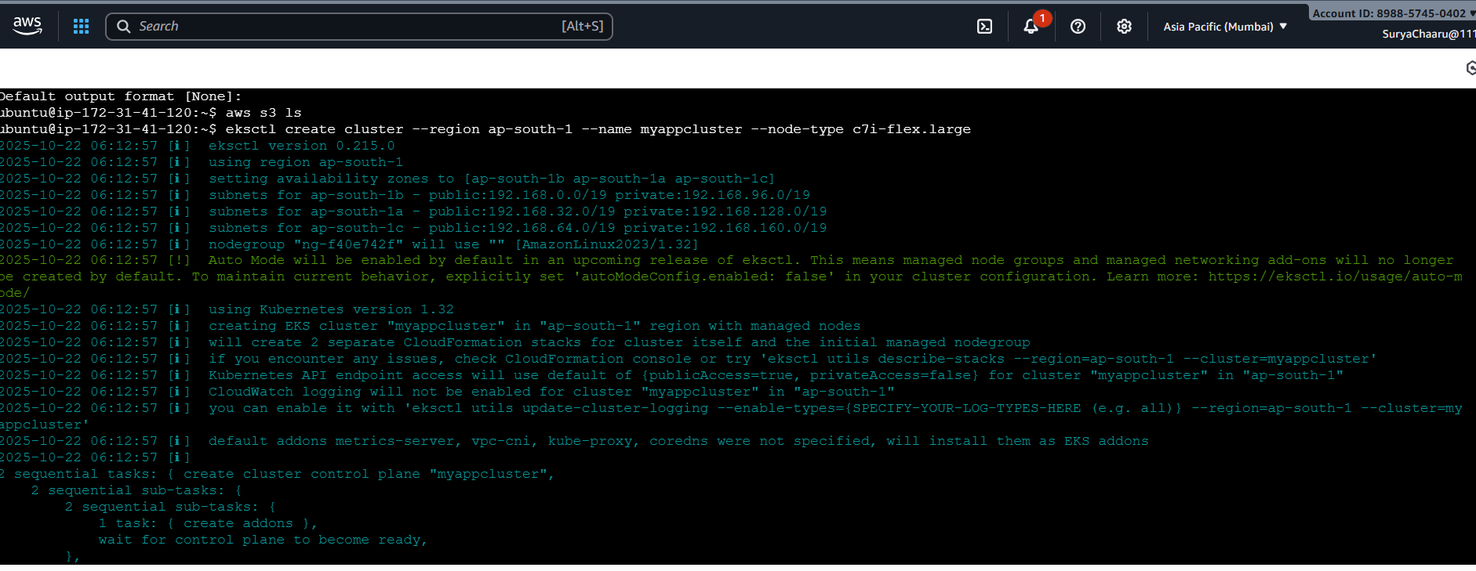

Node group with nodes

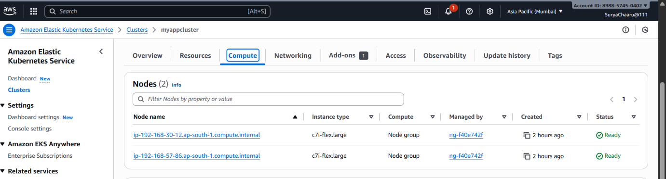

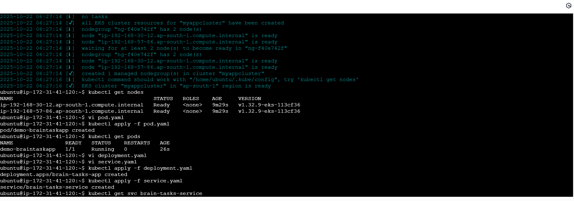CodeBuild:

Created a CodeBuild project:

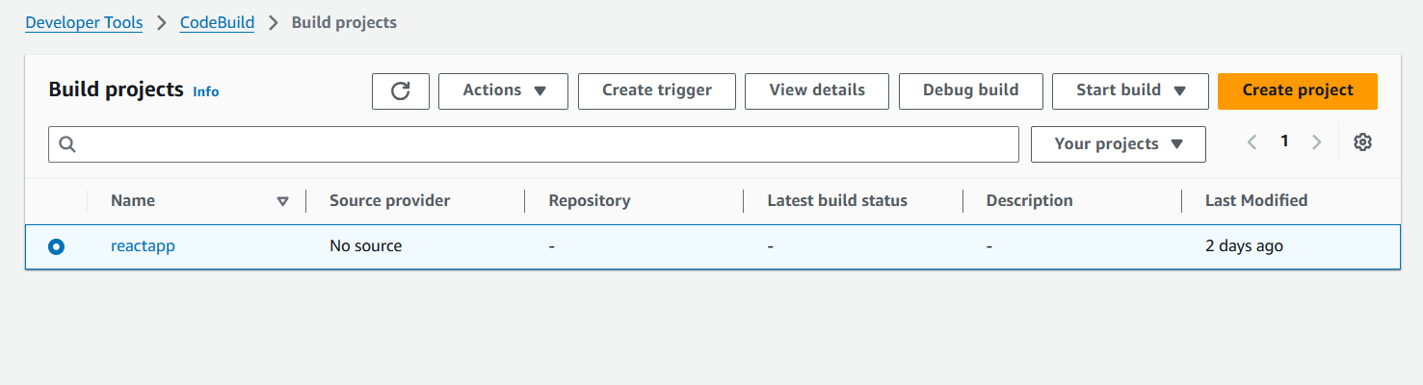

Source: Connect to your repository

<https://github.com/Bhuvisai22/Project-1>

Environment: Amazon Ubuntu

Written buildspec.yaml

aws codebuild batch-get-builds --ids your-build-id

CodeDeploy:

Create codedeploy application.

create appspec.yml file to deploy applications in EKS.

Version Control:

Pushed file to GIT repository

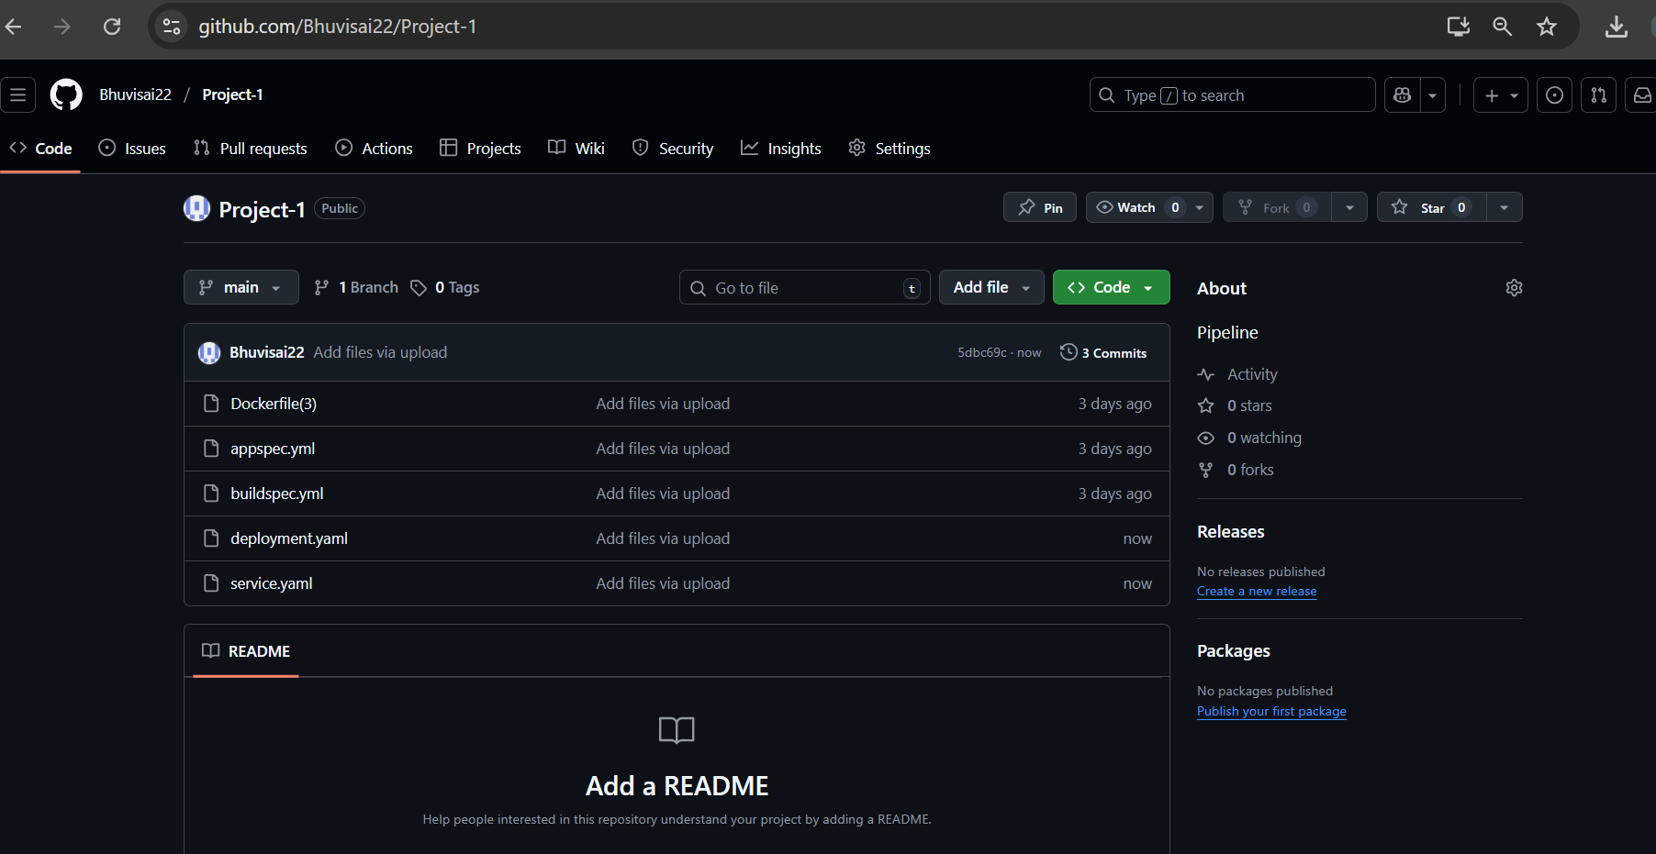

By using CLI commands

git init

git branch -M main

git add .

git commit -m "Initial commit: add full application code"

git remote add origin https://github.com/Bhuvisai22/Project-1.git

git push -u origin main

CodePipeline:

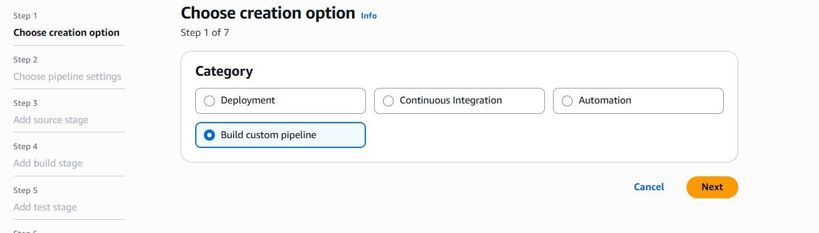

Source: GitHub

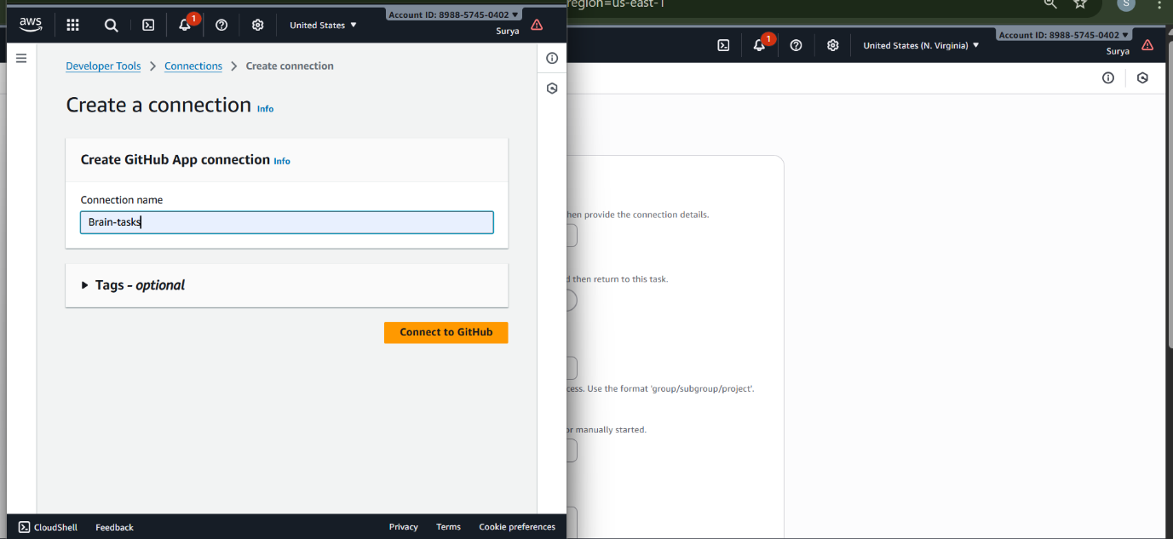

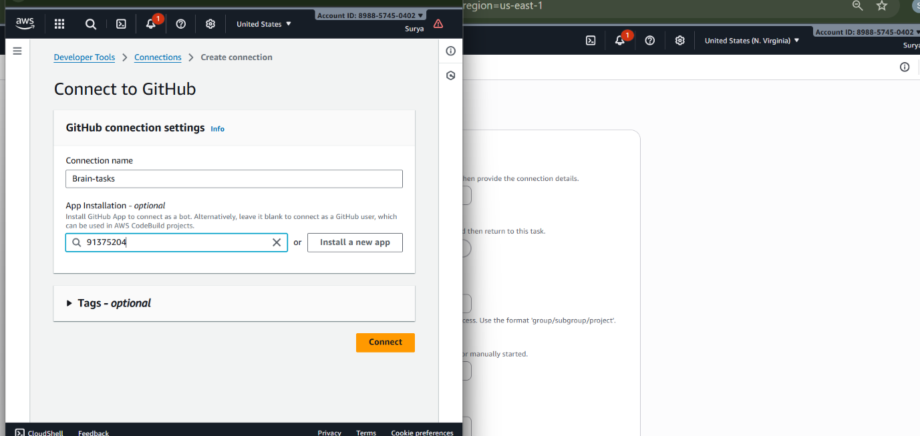

Deploy: AWS CodeDeploy or deploy to EKS via Lambda or custom script.

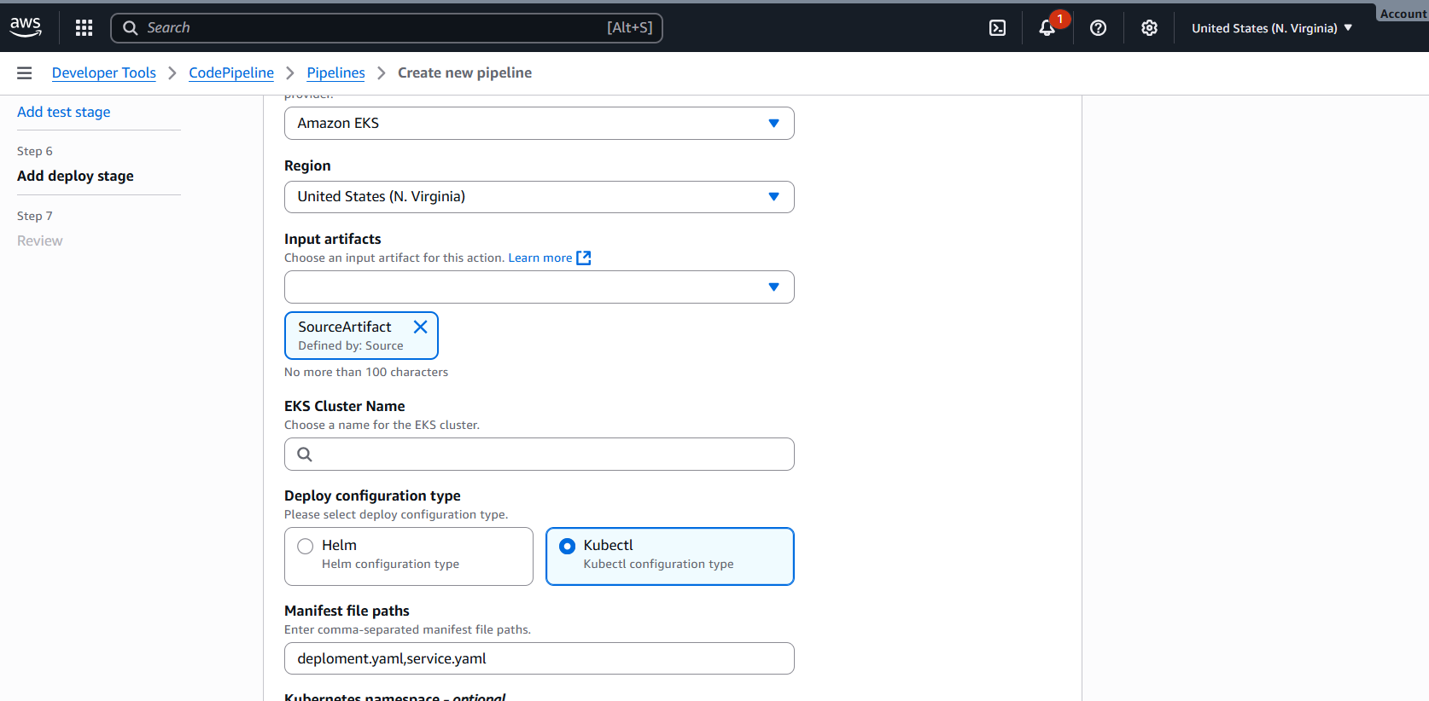

Due to AWS account issue can’t able to make this step. There is no quota for codebuild also tried by changing the location, got an error (Not deployed)

